Volunteering is one of the most rewarding things you can do. Think about why you might want to volunteer.
- Gain confidence. Volunteering can help you gain confidence by giving you the chance to try something new and build a real sense of achievement.
- Make a difference. Volunteering can have a real and valuable positive affect on people, communities and society in general.
- Meet people. Volunteering can help you meet different kinds of people and make new friends.
- Be part of a community. Volunteering can help you feel part of something outside your friends and family.
- Learn new skills. Volunteering can help you learn new skills, gain experience and sometimes even qualifications.
- Take on a challenge. Through volunteering you can challenge yourself to try something different, achieve personal goals, practice using your skills and discover hidden talents.
- Have fun! Most volunteers have a great time, regardless of why they do it.

Search for local opportunities near you on the National Volunteering Website:
www.volunteerscotland.net/find-an-opportunity/opportunity-search/
or
To find out more about volunteering in the Highlands, visit NHS Highlands Volunteer Page (http://www.nhshighland.scot.nhs.uk/Careers/Pages/Volunteer.aspx) or one of the voluntary organisations near you to discover a whole range of different opportunities, from pet sitting to befriending.
CVS North: www.cvsnorth.co.uk
Volunteering opportunities not yet listed.

Caithness Volunteering info: www.cvg.org.uk/volunteering/opportunities/
Includes a list of local opportunities.

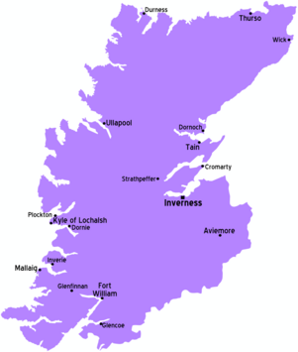
Ross-shire Voluntary Action: www.rossvolact.org.uk
Local volunteering section currently being developed.

Signpost Partners: -
http://signpost-inc.org/volunteering/
Badenoch & Strathspey Volunteering form:
http://www.vabs.org.uk/wp-content/uploads/2015/10/Volunteer-Registration-Form.pdf

Voluntary Groups East Sutherland: www.vges.org.uk/Volunteering/
Young person’s volunteering: http://www.vges.org.uk/Volunteering/Under25.html

Lochaber Voluntary Action: http://valochaber.org/volunteering/volunteering-opportunities/

Skye & Lochalsh: http://www.slcvo.org.uk/volunteering.htm

